School

Academic year 2009/2010

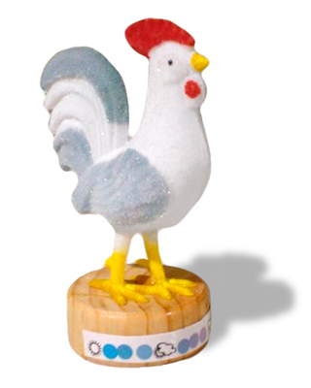Disciplinary Physics and Chemistry

1.3 Laboratory activity: Effects of concentration and temperature in an overall increase in chemical equilibrium system.